

PASTOR ALBERT PETERSON II

Welcome to Our Guests

**Victory Seventh-day Adventist Church**

1271 Burke Avenue, Bronx, N.Y. 10469 | Phone: 718.405.0632 | Fax: 347-899-8211

E-mail: victory_sda | Website: [www.victorysda.org](http://www.victorysda.org)

Watch us live Saturdays @ 11:00 am – www.vsdabn.org

**Sabbath, October 12, 2019**



**ON DUTY TODAY**

**PLATFORM COORDINATOR…………………...………………………....**Elder Dean Barrett  
**CHURCH CLERK………….………………………...…………....**Sis. Sylvian Vigo Wellington

**ON DUTY EVERYDAY**

Senior Pastor **Dr. M. G. Gegory:**  mgmilory@gmail.com 914-572-1611

Associate Pastor **Albert B. Peterson II**: peterson.albert@yahoo.com 412-608-6220

First Elder **Elder Leslie Pitterson:** lcpitterson@gmail.com 914-473-7912

Head Deacon Deacon Colville Fraser

Head Deaconess Deaconess Sheena Belle

Adventist Youth Director Sis. Monique Fraser

Communications & Multi-Media Elder Barrington Anderson

Community Services Leader Sis. Claudette Hall

Health Ministries Director Sis. Lorraine Taylor-Bogle

**Family Life Ministries**  Bro. & Sis. Horace Appleton   
*-* Men’s Ministry Bro. Eric A. Thomas

- Women’s Ministry Sis. Myrna Harris  
 - Singles' Ministry Sis. Vernetta Collins

Pathfinder Director Bro. Channa Smith

Personal Ministries Coordinator Elder Franklin Julius

Sabbath School Leader Sis. Barbara Humphrey

**OUR CHURCH IN SERVICE**

|  |  |
| --- | --- |
| ***QUICK VIEW OF EVENTS CALENDAR!*** | |
|  | **ADVENTURER APPLE PICKING TRIP – October 13, 2019** |
|  | **NATIONAL DIABETES PREVENTION PROGRAM – October 15, 2019** |
|  | **ADVENTURER AND PATHFINDER DAY – October 26, 2019** |
|  | **COMMUNITY GUEST DAY – November 9, 2019** |

**Victory Seventh-day Adventist Church**

1271 Burke Avenue, Bronx, N.Y. 10469 | Phone: 718.405.0632 | Fax: 347-899-8211

**"SEEING IS NOT ALWAYS BELIEVING”**

NOV.

OCT.

OCT.

OCT.

**PLATFORM DECORUM  
Platform participants are to meet with the presiding Elder in the Conference Room at 10:45 AM**. **Our dressing – males and females - should reflect our realization that we   
are in the presence of our Lord and God--the Holy one. Participants seated on the platform will exit the platform once he/she has completed the worship service assignment. Please remain alert to the part you must play in the service. Please speak directly into the microphones. Do not turn microphones off or tap microphones!**

**PASTORS’ VESTRY HOURS**

**TEL: (718) 405-0632, (347) 899-8210**

**Wednesdays, 6:00 PM –7:30 PM**

**During Vestry hours, the Pastor may do house visits; it is advised to call ahead to ensure  
that he is present in the office.**





**SABBATH SCHOOL - 9:15 AM - 10:40 AM**

Song Service

Sabbath School Superintendent’s Remarks

Prayer

Hymn of Worship

Scripture Reading

**THE SABBATH SCHOOL LESSON REVIEW**

Lesson Summary

Welcome

Special Music

Mission Emphasis

Sabbath School Supt’s. Closing Remarks

Special

**PERSONAL MINISTRY – 10:40 AM - 10:50 AM**

**Personal Ministries Presentation**

Sabbath School Closing Prayer

**THE CHURCH AT STUDY**

**SUNSET CALENDAR**  
 Today, Sabbath, October 12, 2019 – 6:22 PM  
 Next Week Friday, October 18, 2019 – 6:13 PM





**11:00 AM - 1:00 PM**

Prelude ***{# 692 - “The Lord Is In His Holy Temple”}*** Praise Team/Choir/Organist

Introit {Platform Party enters} “***All Hail The Power of Jesus Name”*** Congregation

Call to Worship Elder Franklin Julius

Doxology ***“Praise God from Whom All Blessings Flow”*** Congregation

Invocation Pastor Albert Peterson II

Church Announcements Sis. Sylvian Vigo-Wellington

**WE FELLOWSHIP & PRAISE**

*+Welcome ***“Smile Everybody Smile”*** Sis. Shelli-Dawn Ingram

Pastoral Emphasis Pastor Albert B. Peterson II

Praise & Worship Praise Team

**WE FELLOWSHIP & PRAISE**

+Opening Song ***#195 “Showers of Blessing”*** Congregation

*Intro. To Prayer **#483** ***“I Need Thee Every Hour”*** Praise Team +Intercessory Prayer Elder Harry Draggon

Response ***“Hear Our Prayer O Lord”*** Praise Team

Children’s Story Moment Elder James Murray

Musical Selection Sis. Shelly-Ann Brown

+Tithe & Offerings Bro. Horace Gardner

Response ***"We Give Thee But Thine Own”*** Congregation

+Scripture Reading ***John 4:47-48 (NLT)*** Bro. Marquise Morrison

Introduction of Speaker Sis. Shantel Campbell

Meditation Song Sis. Shelly-Ann Brown

**The Spoken Word Pastor Albert Peterson II**

**"SEEING IS NOT ALWAYS BELIEVING"**

Closing Hymn #***248 “O How I Love Jesus”*** Elder Franklin Julius

Benediction Elder Franklin Julius

Response **#214 *“We Have This Hope”*** Congregation

Recessional Organist

**REVERENCE FOR GOD’S SANCTUARY**

**Thank you for worshiping at the Victory Seventh-day Adventist Church. If you are visiting for the first time we pray the worship activities will enrich you spiritually. Congregation, as your act of reverence for God’s Sanctuary, please wait to be ushered from the Sanctuary.**

**CHURCH AT WORSHIP**



**VICTORY SEVENTH-DAY ADVENTIST CHURCH**

**MISSION STATEMENT**

When **Nelson Mandela** was studying law at the University, a white professor, whose last name was Peters, disliked him intensely. One day, Mr. Peters was having lunch at the dining room when Mandela came along with his tray & sat next to the professor. The professor said, ***"Mr. Mandela, you do not understand, a pig and a bird do not sit together to eat"*** Mandela looked at him as a parent would at a rude child and calmly replied, ***"You do not worry professor. I'll fly away,"*** and Mandela went and sat at another table. Mr. Peters, reddened with rage, decided to take revenge. The next day in class he posed the following question***: "Mr. Mandela, if you were walking down the street & found a package, and within was a bag of wisdom & another bag with money, which one would you take?"***

Without hesitating, Mandela responded***, "The one with the money, of course."*** Mr. Peters, smiling sarcastically said, ***"I, in your place, would have taken the wisdom".*** Nelson Mandela shrugged and responded, ***“Each one takes what he doesn't have."*** Mr. Peters, by this time was about to throw a fit, seething with fury. So great was his anger that he wrote on Nelson Mandela's exam sheet the word ***"IDIOT"*** and gave it to the future freedom struggle icon.

Mandela took the exam sheet and sat down at his desk trying very hard to remain calm while he contemplated his next move. A few minutes later, Nelson Mandela got up, walked up to the professor & told him in a dignified polite tone, ***"Mr. Peters, you signed your name on the sheet, but you forgot to give me my grade."*Object Lesson:May the Lord give us wisdom to respond to our enemies with wisdom and not hate! Don't hate back; instead apply wisdom!**

The mission of the Victory Seventh-day Adventist Church is to foster a nurturing, caring community of believers, united in proclaiming the gospel, within the context of the Three Angels Messages of Revelation 14: 6–12

WORSHIP SERVICE DECORUM

* Congregation, please mute or turn off all cell phones.
* We broadcast our services live every Sabbath. Please refrain from any movement, activity or conversation which may transmit unfavorable messages to our online guests and others!
* During the Service, please try to refrain from exiting and entering the Sanctuary during the Intercessory Prayer, Prayer Response, Meditation, Offertory, and Special Music. If you must do so, please exit or enter as discreetly as possible.
* Please help keep the church building in a manner befitting God’s House. Please do all you can to keep it and its furnishings in the way God expects us to, and refrain from excessive noise in the Sanctuary always!
* Please leave the sanctuary in a reverent manner. All conversation should take place in the foyer or in the fellowship hall after the service.
* Keep in mind that since the Church is the House of God, His Kingdom on earth, we should all dress properly to maintain the sanctity of the services and reflect proper respect. Our dressing – males and females - should reflect our realization that we are in the presence of our Lord and God-the Holy one.

# IN THE SPIRIT OF WORSHIP



**TODAY, OCTOBER 12, 2019**

**BIBLE CLASS:** 3:00 PM

**CHILDREN'S BIBLE TIME:** 3:30 PM

**ADVENTIST YOUTH MINISTRY (AYM):**  4:00 PM

**TOMORROW, OCTOBER 13, 2019**

**PRAYER MINISTRY:** Meets 6:00 AM here at Victory. Let us be united in prayer. Bring someone with you.

**ADVENTURER APPLE PICKING TRIP:** Please join the Adventurers as they head out to their annual apple picking trip at Weed Orchard & Winery, 43 Mount Zion Road, Marlboro, NY 12523. Departure time is 9 AM sharp. Admission and parking are free; full bag of apples cost $40.

**NEXT WEEK’S EVENTS**

**SUBMISSION OF ANNOUNCEMENTS:** The deadline for all announcements and inserts for the weekly printed worship program is no later than WEDNESDAYS of each week. Information should be emailed to victory_sda@hotmail.com. Announcements or inserts submitted after this date **WILL NOT BE INCLUDED.**

**RECURRING EVENTS**

**COMMUNITY SERVICES DEPARTMENT:** Hot meals are served every Sunday to the

community and shut-ins, from 10:30 AM to 1:30 PM.

**VICTORY LEISURE “KLUB”:** The Victory Leisure Klub meets the 3rd Wednesday of

each month at 11am – 1pm. Invite a senior in your community or home to this Klub.

**VAN MINISTRY MEETINGS:** Every first Tuesday of the month. Team members and volunteers are invited to attend.

**UPCOMING EVENTS**

**NATIONAL DIABETES PREVENTION PROGRAM:** The program is held each Tuesday evening from 7:00 PM - 8:00 PM

**ADVENTURER & PATHFINDER INVESTITURE:** The Adventurer & Pathfinder Investiture will be on ***October 26, 2019.***  **COMMUNITY GUEST DAY:** Our Community Guest Day is on ***November 09, 2019.*** Guest speaker is Pastor Elias Zabala, Treasurer of the Atlantic Union Conference  
**SIGHT & SOUND TRIP:** Please secure your tickets for the upcoming Sight & Sound trip ***November 13, 2019***. First come, first served so get your tickets early and secure your seat. Please see Sis. Rena Campbell for more details.  
**CHILDREN’S MINISTRY:** The Children’s Holiday party will be on December 15, 2019 at 1 PM – 3 PM in the Fellowship Hall, for the children of the church and the community. Kindly bring your toy donations to Sis. Joy Adams or Sis. Maulene Pitterson before the date.

**PERSONAL MINISTRIES:** The Personal Ministries Department will be going into the community in Sector 8 & 9 on October 19, 2019 for Door to Door Evangelism immediately after Divine Service. Members of unit 8 and 9 are reminded to join the team. Visitors and members are also welcomed to participate. Don’t forget to bring your comfortable footwear!

# CHURCH ANNOUNCEMENTS

***OCTOBER BIRTHDAYS & ANNIVERSARIES***

# CHURCH ANNOUNCEMENTS

**BIRTHDAYS*: (Bold text are the current birthdays for announcement today)* 6th – Sheena Belle, Ataliah Underwood, Maureen Campbell, Edwin Wiggan; 8th – Horace Gardner, Neville Dixon, Franklin Smith; 9th – Alicia Jacobs; 12th – Carlene Plummer;** 13th – Anastasia Gardner; 14th – Christopher Shaw; 15th – Joanna Smith, Karen Spence; 16th – Levi Dell, Audrey Hendricks, Rassine Stewart, Eric A. Thomas, Rosalind West; 18th – Keith Gordon; Mortimer Brown, Jr. 19th – Ann-Marie Beckford; 20th – Devin Barrett, Darien LaBorde, Sophia Underwood; 21st – Alvin Adams; 23rd – Herlin Morgan; 24th – Shannon Shirley, Domonique Shirley, Krystle-Dawn Connell; 25th – Channa Smith, Ashley Peterson, Ngalla Dixon; 29th – Novlette Maitland, Kenneth Newman

**WEDDING ANNIVERSARIES:**

**2nd – Bro. Eaton & Orlean Harding (34 years) 4th – Elder & Sis. Franklin Julius; 14th - Bro. & Sis. Keith Gordon; 16th – Bro. & Sis. Milton & Eulalee Mattis; 21st – Bro. & Sis. Dennis McMurrin**

**LET’S GET PHYSICAL & HEALTHY:**  
Exercise classes continue every Monday and Thursday from 7:00 PM - 8:00 PM in the fellowship hall. The program is now directed by Victory’s fitness trainers who were trained by the **National Academy of Sports Medicine** and Certified by **Athletics Fitness Association of America**.

**SICK AND HOME MEMBERS:**Please call or visit: Please call or visit: Francis Francis, Milton Mattis (Workmen’s Circle Multicare Center) Sis. Daphne Isaac (Regeis Care Center),Lucita Gordon, Marcia Williams, Maureen Campbell, Daphne Isaacs, Paulette Newman, Coragine Bachelor, Novelette Maitland, Linda Charles 347-275-3242 Bros. Romel May – 347-495-5808, Benoni Harris – (Kings Harbor Nursing Home) 718-379-5138, Jocelyn Isaacs – (Bay Park Nursing Home), Cargil Tomlinson

**PRAYER LIST:**

Please continue to keep in your prayers:Bros. James Acheaw, David Willis, Cleveland Pearce,Jieraun Benjamin (US Navy), Julian Benjamin (US Air Force), Vaughn Davis (US Army), Carlton James Jr. (US Marine Corps), Oliver Qutel (US Marine Corps). Sis. Jhenelle Bryan (US Air Force), Kris-Ann Foreshaw (US Navy).



PLEASE DINE WITH US AT OUR LUNCHEON  
IMMEDIATELY AFTER DIVINE SERVICE. JOIN US!

Next Sabbath Will Be Our Potluck Luncheon





# COMING EVENTS



|  |
| --- |
|  |
|  |
|  |
|  |
|  |
|  |
|  |
|  |
|  |
|  |
|  |
|  |
|  |
|  |
|  |
|  |
|  |
|  |
|  |
|  |
|  |
|  |

# SERMON NOTES

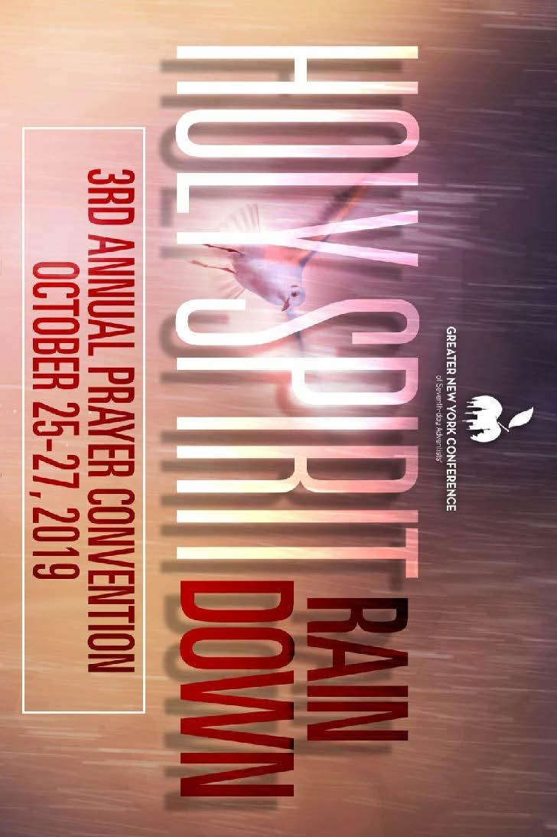

# COMING EVENTS

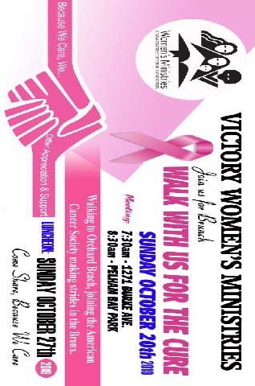

# COMING EVENTS



# COMING EVENTS

